**Sytesafs: Azure Blobs**

**Account Name:** sytesafs

**Connection String:**

DefaultEndpointsProtocol=https;AccountName=sytesafs;AccountKey=CJpPJYkveinaoHuhEPAiX3O+lcxqrodGgawgJ0764XJbNjjeUXH6zsuCNffJrPhyaeaGOgXFnmntBmK1gsfRBA==;EndpointSuffix=core.windows.net

**Access Key:**

CJpPJYkveinaoHuhEPAiX3O+lcxqrodGgawgJ0764XJbNjjeUXH6zsuCNffJrPhyaeaGOgXFnmntBmK1gsfRBA==

**URI**: <https://sytesafs.blob.core.windows.net/>

**Container:** fs1

**Tipo de blob a subir**: *Block blob*

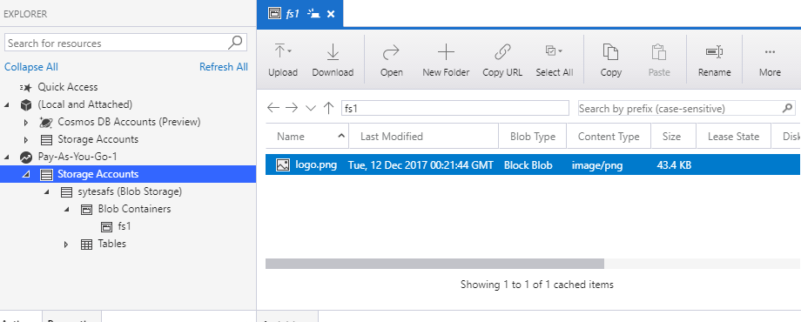

**Documentación REST API**:

<https://docs.microsoft.com/en-us/rest/api/storageservices/blob-service-rest-api>

**Caso de Uso**:

<https://docs.microsoft.com/en-us/azure/storage/common/storage-rest-api-auth>

<https://channel9.msdn.com/Events/Microsoft-Spain-Events/Microsoft-Azure-Deep-Dive/1-Basic-14-Introduccin-a-Azure-Blob-Storage>